Installation, Operation and Maintenance Manual
PROVAL A100 PRO Series
Basic & Integrated Electric Actuators

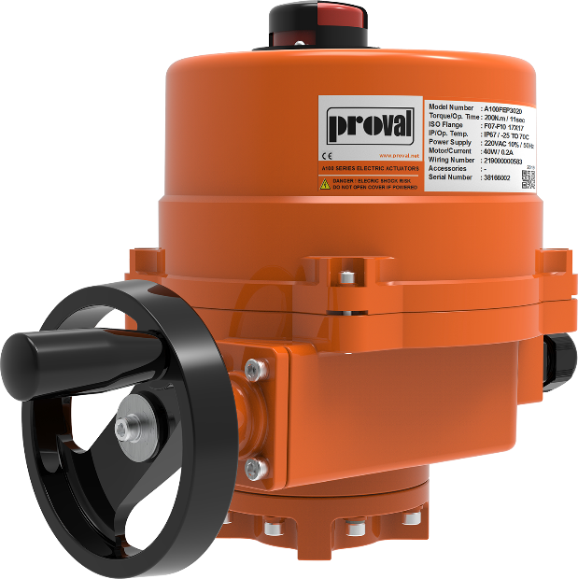



IOM-A100-2501-R0

INDEX
Section 1: Before You Start 2
1.1 Base Safety Procedures 2
1.2 Protection 2
1.3. Instructions for Shipment & Warehousing 3

Section 2: Introduction 4
2.1 Overview 4
2.2 Parameters 4
2.3. PRO Series Parameters 4
2.4. Installation of Actuators 5
2.4.1 Installation Procedure 5
2.4.2 Wiring Procedure 5
2.4.3 Adjustment of Cam and Limit Switch 6
2.4.4 Mechanical Stop Adjustment 8
2.4.5 Configuration of Modulating Actuators 9
2.4.5.1. Single Phase Series Modulating Actuators 10
2.4.5.2. DC Power Series Modulating Actuators 14
2.4.5.3. Three Phase Series Modulating Actuators 19
2.5. Dimensions 21

Section 3: Service & Maintenance 23
3.1 Troubleshooting 23
3.2 Maintenance 24

IOM-A100-2501-R0

Section 1: Before You Start
This section explains:
- Base Safety Procedures
- Protection Guidelines
- Storage Guidelines
- Handling Guidelines
Installation, adjustment, putting into service, use, assembly, disassembly and maintenance of the actuators must be performed by qualified personnel / electricians only.
WARNING !

Nonobservance of the safety instructions may lead to personal injury and danger for both the environment and the valve/actuators itself. Nonobservance of these safety instructions will also forfeit the user’s warranty

1.1 Base Safety Procedures

-Personnel making any adjustments to the valve/actuators should utilize suitable equipment. All required personal protection means should be worn.
- Installation and handling of the valve/actuators should only be done by personnel that is trained in all aspects of manual and mechanical handling techniques.
- Ensure that valve/actuators pressure/temperature limitations marked on the valve/actuator nameplate are within the service conditions.

1.2 Protection
Proval actuators are delivered with protection under the Proval Engineering Instructions, to protect the valve/actuators from damage. Wrapping and/or covers should be left in place until installation of the valve/actuators.

1.3 Instructions for Shipment & Warehousing
Adequate packing must be used for shipment and storage depending on shipment type and stocking options. Actuators / valves must be protected from atmospheric conditions and external damage at all times. Special packing types may be used for overseas shipments.
The coating applied for corrosion control must be protected against mechanical damage at all times.
Some valves are delivered with an electric actuator. If this is the case, make sure actuators are protected from atmospheric conditions and mechanical damage. Pay special attention to the safety of the actuator, while lifting or moving the valve.
Large-size valves do not have their center of gravity in the middle due to their gearbox so may swing sideways during lifting operation. Lifting operations must be made with special care and nobody except the operator must enter the area during lifting operations.
Avoid sudden movements during the lifting, moving, and lowering of the valve. Such sudden motions may damage the valve and/or lifting system. Make sure the capacity of lifting equipment is adequate to lift the valve you are working with. Make sure general regulation regarding lifting heavy equipment is applied during the lifting process.
Some valves are packed in wooden crates or boxes depending on shipment methods. Make sure the instructions on the crate are applied during offloading and loading. While working with such crates/boxes, the center of gravity for the whole crate/box must be taken into consideration.
Valves must be kept in a slightly open position during storage to protect the sealing ring. Sealing rings must be protected from atmospheric effects and direct sunlight. Valves must be kept in dry, clean, and well-ventilated areas and they must be kept away from direct sunlight otherwise long-term sealing performance cannot be guaranteed.
The valves/actuators must be protected from dust and other types of dirt during storage. Special care must be given to protect the sealing ring and body seat from mechanical damage.
Transport and storage temperature between -30°C ~+50°C. The storage temperature should not constantly be more than 40°C to maintain a normal product lifespan.
Under the unpacked condition, store the actuator in the dry room to avoid condensation occurrence. The electrical chamber is equipped with a space heater, which should be regularly connected with power to keep the chamber dry.
When storage is in humid and corrosive gas conditions, there must be proper packing and desiccant placed. Check the desiccant periodically for date validation.
To ensure product quality, each actuator has to pass strict inspection before leaving the factory. Please make sure of the correct unpacking position as directed on the exterior of the packing. Check the following:
- If the actuator has been damaged during transportation.
- The model number is identical with container label and the packing list

Section 2: Introduction

2.1 Overview

A100 FEP Series electric actuators are well-designed and suitable for butterfly valves, ball valves, dampers, and other part-turn control requirements. Aluminum alloy structure housing makes the actuators lighter and more durable in industrial process controls. Meanwhile, to ensure the internal circuit is free from wetness, both moisture-proof resistor and closed-type seal structure designs are provided according to IP67 standards. Therefore, it is widely used in fields like petroleum, the chemical industry, water solutions, marine, etc.

2.2 Parameters

Voltage ： Single phase - 110/120/220/230/240, 50Hz/60Hz.
Three phase - 220/230/240/380/440/460/480, 50Hz/60Hz., DC – 24VDC
Amb.Temperature ：-25°C ~70°C, Operating Temp : -40°C ~70°C
Humidity ：≤95% RH(25°C)
Duty cycle ：On/off：S2-15min; Modulating：S4-50%
Motor Protection ：F grade insulation, dual temperature control protector, protection at 135°C
Ingress Protection ：IP67 (standard), IP68 optional (15m water depth and 72h non-leakage)
Casing ：High strength alloy wheel, epoxy powder coating NEMA 4X grade
Cable adaptor ：1 NPT 1 1/2“, 2 NPT 3/4”, M18, M20
Control signal ：On/Off - digital signal control; Modulating：4-20mA/0-10V/2-10V analog control
Feedback signal ：On/off - Dry contact Position Feedback;（rated 5A @250V AC），
Modulating - 4-20mA/0-10V/2-10V position analogue feedback
2.3 PRO / PROEx Series Parameters

Model |  | Torque (Nm) | Running Time(Sec) |  |  | Motor Power (W) | ISO5211 Flange
 |  | Torque (Nm) | DC | 1 Ph | 3 Ph | Motor Power (W) | ISO5211 Flange
Standard | Ex-Proof | Torque (Nm) | DC | 50Hz |  | Motor Power (W) | ISO5211 Flange
PRO030 | - | 30 | 11 |  | - | 10 | F03/F05
PRO050 | PROEx005 | 50 | 10 | 15 | - | 10 | F03/F05/F07
PRO080 | PROEx008 | 80 | 15 | 22 | - | 10 | F03/F05/F07
PRO100 | PROEx010 | 100 | 14 | 19 |  | 40 | F05/F07/F10/F12
PRO200 | PROEx020 | 200 | 28 | 39 |  | 40 | F05/F07/F10/F12
PRO300 | PROEx030 | 300 | 28 | 39 |  | 40 | F05/F07/F10/F12
PRO400 | PROEx040 | 400 | 21 | 29 |  | 90 | F10/F12/F14
PRO600 | PROEx060 | 600 | 28 | 39 |  | 90 | F10/F12/F14
PRO800 | PROEx080 | 800 | 34 | 47 |  | 90 | F10/F12/F14
PRO1000 | PROEx100 | 1000 | 34 | 47 |  | 120 | F10/F12/F14
PRO1700 | PROEx170 | 1700 | 25 | 34 |  | 200 | F12/F14/F16
PRO2300 | PROEx230 | 2300 | 34 | 47 |  | 200 | F12/F14/F16
PRO3500 | PROEx350 | 3500 | 55 | 76 |  | 200 | F14/F16
PRO5000 | PROEx500 | 5000 | 76 | 105 |  | 200 | F14/F16
PRO8000 | PROEx800 | 8000 | 103 | 143 |  | 200 | F25
PRO13000 | - | 13000 | - | 109 |  | 400 | F25/F30
PRO16000 | - | 16000 | - | 129 |  | 400 | F25/F30
PRO20000 | - | 20000 | - | 155 |  | 400 | F25/F30
  - Installation of Actuators

2.4.1. Installation Procedure

Below figures are for reference only, actual product shape may vary from below images.

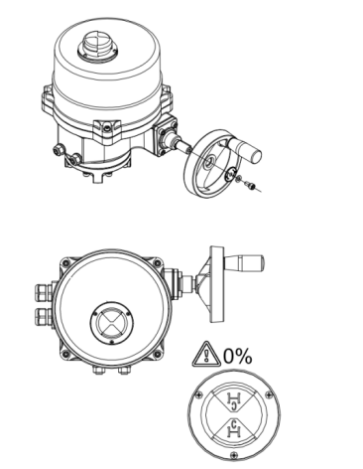
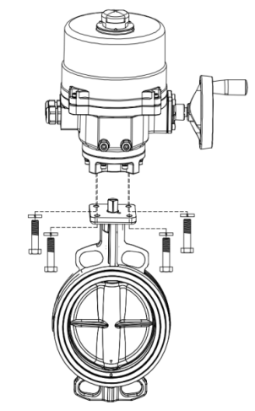
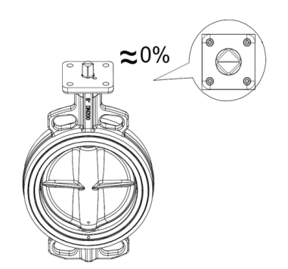
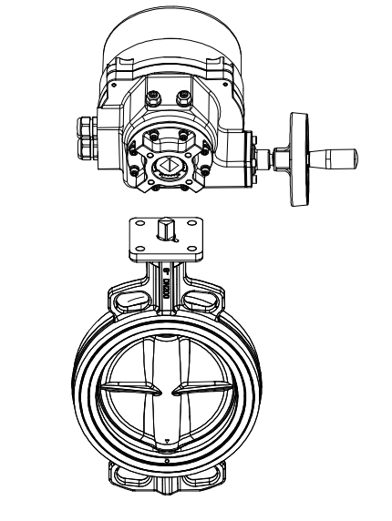
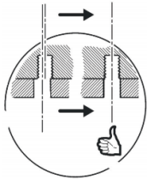




Put the actuator on the valve, and make the hole of the flanges aligned by operate the wheel.
Install the hand wheel and make the actuator fully closed.
Tighten the screws
Fully closed the valve

2.4.2 Wiring Procedure

Before starting the wiring, please ensure the wiring diagram is matching with the diagram number on the actuator label.

  - Loosen the screws and remove the protective cover.
  - The wiring work shall be according to the wiring diagram attached.
  - In the case of wiring, pull out the rubber plug of the waterproof joint, and then insert the cable, through the waterproof joint, into the electric actuator. Once the wiring is finished, rotate the bolt of the waterproof joint clockwise.
  - Check and verify that the actuator is energized after proper wiring.
  - Carry out a trial run for the actuator to check whether the operating direction and limit device are under proper condition.
  - After confirming all functions are normal, install the protective cover and tighten the screw.

To ensure the water resistance and normal use of the electric actuator, the cable shall be constructed according to the following requirements:
- Cables shall be selected according to the actual cable joints:
- PG13.5 6 to 12 mm diameter sheath cable
- PG16 10-14 mm diameter sheath cable
- M20 10-14 mm diameter sheath cable
- M25 10-14 mm diameter sheath cable
- NPT3/4 9-15 mm diameter sheath cable
- NPT1/2 6 to 12 mm diameter sheath cable
- Special shielded cable shall be selected for the signal cable.
- The power line and signal line shall be connected by 2 cables
- The locking cable joint shall be selected with a special fixed wrench. No movable wrench or pipe pliers shall be used
- If the pipe access mode is adopted, the waterproof pipe joint of the corresponding specification should be replaced
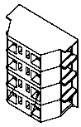
Push into holes

Wire connection holes
Terminal Blocks

Attention !

1. Do not power on before complete the wiring and inspection; otherwise, short circuit and false wiring will cause permanent damage to the equipment!
2. Please monitor the indicator. Once exceeded the full open or full close position, do not brutally operate the hand wheel/handle or the actuator will be damaged!

2.4.3 Adjustment of Limit Cam and Limit Switch

All the Following settings have been completed before the ship out. Do not readjust the actuator. If necessary, like over travel, jamming, or poor tightness/leakage on the valve.

The stroke limit cam and limit switch are used to sensor the switching position of the valve. When the valve reaches the limit position, the cam makes the limit switch reset. On/Off type actuator is normally equipped with four limit switches (SLO1&SLC1, SLO2&SLC2): SLO1&SLC1 respectively refers to the open/close limit switch, while SLO2&SLC2 are auxiliary limit switches, used for signal feedback. The modulating actuator is normally equipped with two limit switches (SLO1 & SLC1): SLO1 is an open limit switch, and SLC1 is a close limit switch. (It is easy to distinguish them by reference to the figure below)
Do not regulate the switches when the electric valve can operate normally. If necessary, please follow the instructions below:

Calibration of fully-closed position:

- Shut down the power
- Fully close the valve by manual operation
- Use a 2.5 mm socket head wrench to release the M5 retaining screw.
- Rotate the SLC1 cam in a counterclockwise direction till touching the micro switch to make the micro switch act.
- Slowly adjust the SLC1 cam in a clockwise direction until the micro switch acts to make a “clatter” sound.
- Lock the M5 retaining screw on the SLC1 cam and switch on the power supply to confirm that the operating position is correct. If the required positioning is not reached, reset it according to the above steps.
- After the setting is completed, reconfirm whether the M5 retaining screw on the SLC1 cam is locked.

Calibration of fully-opened position:

- Shut down the power
- Fully close the valve by manual operation.
- Open the upper cover and loose the M5 retaining screw on the SLO1 cam with a 2.5 mm socket head wrench.
- Rotate the SLO1 cam in clockwise direction till touching the micro switch to make the micro switch act.
- Slowly adjust the SLO1 cam in a counterclockwise direction until the micro switch acts to make “clatter” sound.
- Tighten the M5 retaining screw on the SLO1 cam and deliver power to verify that the operating position is correct. If the desired location is not reached, reset it in accordance with the above steps.
- After the setting is completed, reconfirm whether the M5 retaining screw on the SLO1 cam is locked.

Setting for fully-opened / fully-closed auxiliary limit switch:

The setting for the full close/ full open auxiliary limit switch (SLO2 & SLC2) is the same as that of SLO1 and SLC1 respectively.
M5 Screw
SLC2
SLO2
SLC1
SLO1

SLC1
SLO1

SLC1

SLO1

SLC1 cam “close” CW: reduce the close degree, CCW: increase the close degree to the full close position
SLO1 cam “open” CW: increase the open degree to full open position, CCW: reduce the open degree

2.4.4 Mechanical Stop Adjustment

1. Shut off the power。
2. Loosen the lock nut and pull the mechanical limit bolt out several turns。
3. If it is a modulating actuator, please loosen the fixed screw on the fan gear first。
4. Manually operate the actuator to the desired limit position。
5. For modulating actuators, turn the fan gear clockwise to the bottom, and then lock the upper fixing screw。
6. After turning the mechanical limit bolt to the bottom, turn it back again
7. Lock off limit lock nut。
8. Confirm whether the electric operation can reach the full open and full close position, otherwise follow the
above steps for re-debugging.
Open limit bolt and lock nut

Close limit bolt

Close limit lock nut

PRO100-2300 Series

Open limit bolt and lock nut

Tighten the close limit Lock nut
Close limit bolt

PRO3500-20000 Series

2.4.5 Configuration of Modulating Actuators

2.4.5.1. Single Phase Series Modulating Actuators

All actuators are tested and adjusted at the factory. Unless any change on specifications or re-assembly on new valves, the actuators do not need calibration.
PRO030-050-080 Actuators
Status indicator light
From left to right
D4、D5、D6
S1
S2
S3
S4
VR1
VR2

JP4
JP1
JP2
JP3

Figure 1 PCB of PRO 030/050/080 Electric Actuators
Signal Modulating and Change

The electric actuator has set the input and feedback signal type according to the order requirements at the factory, and the factory default is that the input and output are 4-20mA,. If you need to change the input and feedback signal type, please refer to the jumper shown in the following table.

Signal | Input |  | Output
Signal | JP1 |   JP4 | JP2 | JP3
4-20mA
2-10V
0-10V

Input and feedback can be set separately, such as setting the dynamic actuator to be the input signal of 0-10V, and feedback signal of 4-20mA, which can be set at the jumper position shown in the table below, and if also set to other input and feedback type can only be set in this mode.

Signal | Input |  | Output
Signal | JP1 | JP4 | JP2 | JP3
Input 0-10V
Output 4-20mA

Note: If you need to change the signal type in use, please adjust the professionals.

Signal inversion

The input and feedback signal of the electric actuator can be selected by bits 1 and 2 of the dial switch of S4. The factory default is positive logic (i. e., 4 mA corresponding full off position and 20 mA corresponding full open position). If the logic of input and feedback signal is changed, please refer to the following table:
Status  Bit | OFF | ON
1-Input the signal | 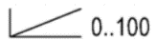 | 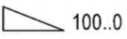
2-Feedback signal |  | 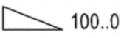

Setting of Input Signal Loss Mode (Applicable to 4-20mA/2-10V)

After the input signal of the electric actuator is lost, the action mode of the actuator can be selected by bits 3 and 4 of the S4 dialing switch. Factory default is running to 0%. If you need to change the signal loss mode, please refer to the following table:
Status  Bit | Running to 0% | Keep the last position | Keep the last position | Running to 100%
3 | OFF | ON | OFF | ON
4 | OFF | OFF | ON | ON

Settings of Actuator

Step 1 | Operation | Indicator Lamp Status
Enter the set state | Power on, press button S1, until the indicator (blue) goes off and the actuator enters the set state | The indicator light (blue) is turned off
Run the actuator to the full-open position | Run the actuator in the full open direction by pressing the S2, release the actuator to stop, press the S3 actuator in the closed direction, release the stop, and run the actuator to the valve full open position in this way. | Run (green) open and (red) in turn off.
Record the position of the valve being fully open | Press the S1, actuator to automatically record the full open position of the valve. | The indicator light (blue) flashes
Run the actuator to the full position | Press the actuator in the full open direction, release the actuator stop, press the S3 actuator in the off direction, release the stop, and run the actuator to the valve full closed position in this way. | Run (green) open and (red) in turn off.
Record the position of the full valve closure | Press the S1, actuator to automatically record the full open position of the valve. | The indicator light (blue) flashes
Set the End | After step 5, the actuator automatically runs to the given position of the signal. | The indicator light (blue) is usually on

Note: When doing the setting procedure, the position of the cam calibration shall be already done (refer to cam adjustment).

PRO100- 8000 Actuators

All actuators are tested and adjusted at the factory. Unless any change on specifications or re-assembly on new
valves, the actuators do not need calibration.
VR1(mA)
VR2(V)
JP4
S4
S1
S2
S3
JP1
JP3
JP2
Red、Yellow、Blue

Figure 2 PCB of PRO 100 / 8000 Electric Actuators
Signal Conditioning and Change

The electric actuator has set the input and feedback signal type according to the order requirements at the factory, and the factory default is that the input and output are 4-20mA,. If you need to change the input and feedback signal type, please refer to the jumper shown in the following table.

Signal | Input |  | Output
Signal | JP1 | JP4 | JP2 | JP3
4-20mA
2-10V
0-10V

Input and feedback can be set separately, such as setting the dynamic actuator to be the input signal of 2-10V, feedback signal of 4-20mA, can be set at the jumper position shown in the table below, and if also set to other input and feedback type can only be set in this mode.

Signal | Input |  | Output
Signal | JP1 | JP4 | JP2 | JP3
Input 2-10V And
Output 4-20mA
Note: If you need to change the signal type in use, please adjust the professionals.

Signal Inversion

The input and feedback signal of the electric actuator can be selected by bits 1 and 2 of the dial switch of S4. The factory default is positive logic (i. e., 4 mA corresponding full off position and 20 mA corresponding full open position). If the logic of input and feedback signal is changed, please refer to the following table:
Status  Bit | OFF | ON
1-Input the signal
2-Feedback signal

Setting of input signal loss mode (applicable to 4-20mA/2-10V)

After the input signal of the electric actuator is lost, the action mode of the actuator can be selected by bits 3 and 4 of the S4 dialing switch. Factory default is running to 0%. If you need to change the signal loss mode, please refer to the following table:
Status  Bit | Running to 0% | Keep the last position | Keep the last position | Running to 100%
3 | OFF | ON | OFF | ON
4 | OFF | OFF | ON | ON

Settings of Actuator

The actuator has been completed from the factory, and when the terminal position of the actuator and valve is required, the following steps can be followed:
Step 1 | Operation | Indicator Lamp Status
Enter the set state | Power on, press button S1, until the indicator (blue) goes off and the actuator enters the set state | The indicator light (blue) is turned off
Run the actuator to the full-open position | Run the actuator in the full open direction by pressing the S2, release the actuator to stop, press the S3 actuator in the closed direction, release the stop, and run the actuator to the valve full open position in this way. | Run (green) open and (red) in turn off.
Record the position of the valve being fully open | Press the S1, actuator to automatically record the full open position of the valve. | The indicator light (blue) flashes
Run the actuator to the full position | Press the actuator in the full open direction, release the actuator stop, press the S3 actuator in the off direction, release the stop, and run the actuator to the valve full closed position in this way. | Run (green) open and (red) in turn off.
Record the position of the full valve closure | Press the S1, actuator to automatically record the full open position of the valve. | The indicator light (blue) flashes
Set the End | After step 5, the actuator automatically runs to the given position of the signal. | The indicator light (blue) is usually on
Note: When setting procedure, the position of the cam calibration shall be already done (refer to cam adjustment).
2.4.5.2 DC Type Modulating Actuators

All actuators are tested and adjusted at the factory. Unless any change on specifications or re-assembly on new valves, the actuators do not need calibration.
PRO030-050-080 Actuators

S1 Set key
S3
S4
20mA calibration potentiometer
Torque calibration potentiometer

Figure 3 PCB of Electric Actuator (PRO 030-050-080)
Signal conditioning and change
The signal type adjustment and change can be modified and corrected with reference to the Sheet below.

Signal type |  | Output Signal | Input Signal
 |  | S4 | S3
mA | 4-20mA
V | 2-10V
V | 0-10V

Current Calibration

Press the S1 calibration key for about 3 sec, and then the actuator will automatically adjust and run to the full travel. Give signal to the actuator to make the actuator run to full open position, and adjust the 20 mA potentiometer until the feedback current is exactly 20 mA. The calibration is done.

The Settings of the Actuator

Press the S1 calibration key for about 3 sec, and the ”D2” indicator light is changed from flashing to normally constantly on, and the actuator is automatically operated in the run to the fully-opened direction.

When the actuator is stopped at the fully-opened position, the”D3” indicator light is turned on and the CPU records the fully-opened closed position and is then automatically runs to the fully-closed direction, and the”D3” indicator light is off again.

Once the actuator is stopped at the full close position, the “D4” indicator light will change from OFF to ON, and the CPU will automatically record the full close position. The “D4” indicator light will change from constantly normally on to flashing. At this point, the setting is finished. The electric actuator will run to the position of the current given signal.

Note: When doing the setting procedure, the position of the cam calibration shall be already done (refer to cam adjustment).
WARNING !

2 Options of PCB boards are available for actuator PRO100-8000 ❗ Please check your actuators installed PCB from below options and perform necessary steps accordingly.

PRO100-20000 series (Option A)
S1 Set key
S3
S4
20mA calibration potentiometer
Torque calibration potentiometer

Figure 4 PCB of PRO 100 / 20000 Electric Actuators

Signal Conditioning and Change

The signal type adjustment and change can be modified and corrected with reference to the Sheet below.

Signal type |  | Input | Output
 |  | S3 | S4
mA | 4-20mA
V | 2-10V
V | 0-10V
Current calibration

The current calibration can be corrected with reference to the steps of the DC series.

Settings of actuator

The actuator can be set with reference to the step of the DC series.

Press the S1 calibration key for about 3 sec, and the ”D2” indicator light is changed from flashing to constantly on, and the actuator is automatically operated in the fully-opened direction.
When the actuator is stopped at the fully-opened position, the”D3” indicator light is turned on and the CPU records the fully- opened position and is then automatically operated in the fully- closed direction, and the”D3” indicator light is off again.
Once the actuator is stopped at the full close position, the “D4” indicator light will change from OFF to ON, and the CPU will automatically record the full close position. The “D2” indicator light will change from constantly on to flashing. At this point, the setting is done. The electric actuator will run to the position of the current given signal.
Note: When doing the setting procedure, the position of the cam calibration shall be already done (refer to cam adjustment).

PRO100-20000 series (Option B)
20mA calibration potentiometer
Signal Conditioning and Change

The signal type adjustment and change can be modified and corrected with reference to the Sheet below:

Signal type |  | Input | Output
 |  | S2 | S3
mA | 4-20mA
V | 2-10V
V | 0-10V
Current calibration

The current calibration can be corrected with reference to the steps of the DC series.

Settings of actuator

Press and hold the feedback signal calibration key S1 for about 3 seconds, and the "D2" indicator light will turn from shining to steady on, and the actuator will automatically run in the direction of full on.

When the actuator stops in the full on position, the D3 indicator changes from off to on, the CPU automatically runs in the full on direction after recording the full off position, and the D3 indicator turns off again.

When the actuator stops in the full off position, the D4 indicator changes from off to on, and the CPU automatically records the full on position. The D4 indicator changes from steady to bright. At this point, the setting ends, and the electric actuator will run to the current position of the given signal.
Signal inversion

The input and feedback signals of the electric actuator can be selected through the first and second bits of the dip switch of S4. The factory default is positive logic (that is, 4mA corresponds to the full off position, 20mA corresponds to the full on position). If you need to change the logic of the input and feedback signals, please refer to the following table:

State  Bit | OFF | ON
Bit 1 |  | 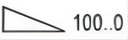
Bit 2

Setting of input signal loss mode (applicable to 4-20mA/2-10V)

After the input signal of the electric actuator is lost, the action mode of the actuator can be selected by the third and fourth bits of the dip switch of S4. The factory default is faithless full off. If you need to change the faithless mode, please refer to the following table:(Lost of signal hold position does not apply for 0-10V)
State Bit | Running to 0% | Keep the last position | Keep the last position | Running to 100%
Bit 3 | OFF | ON | OFF | ON
Bit 4 | OFF | OFF | ON | ON

2.4.5.3 Three Phase Series Modulating Actuators

All actuators are tested and adjusted at the factory. Unless any change on specifications or re-assembly on new valves, the actuators do not need calibration.
PRO100- 8000 Actuators

SW1
SW2
S3 one-key calibration button

20mA calibration potentiometer

Blue LED: Status indicator, Flash is running,
lighting when stroke calibrating.
Red LED: Fault indicator, OFF is normal,
lighting when fault occurred.

Figure 5 PCB of Electric Actuator

Signal conditioning and change

The signal type adjustment and change can be modified and corrected concerning the sheet below.
Signal type |  | Output Signal | Input Signal
 |  | SW1 | SW2
Current | 4-20mA
Voltage | 2-10V
Voltage | 0-10V

Current calibration

After pressing S3 (see Figure 2) for about 3 seconds, the actuator will be automatically adjusted to run a full travel. Give the 20mA to make the actuator to full open position, and adjust the 20 mA potentiometer until the feedback current is exactly 20 mA.
The Setting of the Actuator

Press the S3 calibration key for about 3 sec, and the indicator light is changed from flashing to constantly on, and the actuator is automatically operated in the fully-opened direction.
When the actuator is stopped at the fully-opened position, the indicator light is turned on and the CPU records the fully-opened position and is then automatically operated in the fully-opened direction, and the indicator light is off again
When the actuator is stopped at the fully closed position, the indicator light is turned on the CPU records the fully closed position and the flashing light turns on, the modulating is completed and the actuator will follow the control signal.
Note: When doing the setting procedure, the position of the cam calibration shall be already done (refer to cam adjustment).

2.5 Dimensions
PRO 080
PRO 030-050
PRO 100-2300
PRO 3500-8000

PRO 13000-20000

Dimensions (mm)

Size(mm)  Model | A | B | C | ΦD | E | F | G | ΦH | ΦI | J | Weight  (kg)
PRO030 | 110 | 111 | 87.5 | - | - | - | 11*11 | 16 | 36  50 | 4-M5  4-M6 | 1
PRO050 | 185 | 150 | 82 | 118 | - | - | 11*11  14*14 | 20 | 36  50  70 | 4-M5  4-M6  4-M8 | 3.1
PRO080 | 192 | 150 | 135 | 170 | - | - | 11*11  14*14  17*17 | 20 | 36  50  70 | 4-M5  4-M6  4-M8 | 3.6
PRO080 | 212 |  |  |  |  |  |  |  |  |  | 3.7
PRO100 | 268 | 77 | 123 | 216 | 121 | 240 | 14*14  17*17 | 35 | 70 | 4-M8 | 11
PRO200
PRO400 | 327 | 103 | 187 | 266 | 150 | 297 | 22*22 | 55 | 102 | 4-M10 | 22
PRO600 |  |  |  |  |  |  | 22*22  27*27 | 55 | 102  125 | 4-M10  4-M12 | 22
PRO800
PRO1000 |  |  |  |  |  |  | 27*27 | 55 | 125 | 4-M12 | 22
PRO1700 | 380 | 127 | 242 | 293 | 161 | 333 | 27*27  36*36 | 65 | 125  140 | 4-M16  4-M20 | 36
PRO2300
PRO3500 | 532 | 118 | 242 | 293 | 308 | 186 | 40*40 | 85 | 140  165 | 4-M16  4-M20 | 76
PRO5000 |  |  |  |  |  |  | 46*46 | 85 | 165 | 4-M20 | 76
PRO8000 | 545 | 160 | 242 | 293 | 343 | 160 | 55*55 | 130 | 254 | 8-M16 | 107
PRO13000 | 672 | 520 | - | 293 | 281 | 331 | 55*55  77*77 | 120 | 254 | 8-M16 | 218
PRO16000 |  |  |  |  |  |  |  |  | 298 | 8-M20 | 218
PRO20000

NOTE: "G" is a recommended size, it could be customized according to the corresponding dimension.

Section 3 Service & Maintenance

3.1 Troubleshooting

Fault Situation | Questions | Countermeasures
The electric actuator fails to act | 1.1. No power | 1.1. Check of power supply voltage
The electric actuator fails to act | 1.2. No input signal or input value error | 1.2. Check of input signal
The electric actuator fails to act | 1.3.Disconnection or separation from terminal board | 1.3. Connect the electric wire and replace the terminal block
The electric actuator fails to act | 1.4. Motor overheat protector acts | 1.4. Wait for motor cooling
The electric actuator fails to act | 1.5. The limit switch acts at the intermediate opening position | 1.5. Adjust the cam of travel switch
The electric actuator fails to act | 1.6. Motor operating capacitor is damaged (except for three phases) | 1.6. Replace the capacitor
The electric actuator fails to act | 1.7. Motor winding is damaged | 1.7. Replace the motor
The electric actuator fails to act | 1.8. Improperly connect the heavy current to signal input terminal (adjustable type) | 1.8. Replace the circuit board
The electric actuator acts back and forth, without stop. | 2.1. Signal from signal source is unstable | 2.1. Check the input signal
The electric actuator acts back and forth, without stop. | 2.2. Potentiometer is disturbed or damaged (adjustable type) | 2.2. Replace the potentiometer
The electric actuator acts back and forth, without stop. | 2.3. The potentiometer gear or sector gear is loose (adjustable type) | 2.3. Check the hexagon socket screw of the fastening gear
The input does not match the feedback signal (adjustable type) | 3.1. The input signal is not correct | 3.1. Check the input signal
 | 3.2. The value indicated on the calibration potentiometer is changed (operated by professionals) | 3.2. Reset based on the setting steps
 | 3.3. The position of the potentiometer gear is changed | 3.3. Re-adjust the potentiometer gear
No feedback signal | The opening signal line is disconnected or poorly contacted. | Check whether the wiring mode conforms to the wiring diagram
* Note: In case of the actuator is not electrified after installation, and the dewing phenomenon is detected inside the actuator, please switch on the power supply to eliminate the water vapor by using the internal heater, before operate the actuator again.
3.2 Maintenance

Daily maintenance
Visual inspection of appearance shall be performed to check whether there is any component shortage, looseness, and deformation;

Check whether the actuator is connected to the fixed base firmly, and whether each connector to the main equipment acts flexibly;

Check whether the operation noise of the actuator is abnormal;

Check whether the cables of the actuator are properly connected, and whether the terminal (or plug) wiring is fastened.

Overhaul Cycle
To ensure the firm operation, please perform the following inspection every 12 months:

Check whether the full-travel act for the local manual operation is flexible.

Check whether the control and feedback signals are accurate.

Scrap

When the actuator is used for a long period, or the function failure needs to be scrapped, it is strictly forbidden to throw it away at will, and it is also necessary to find a professional recycling unit for proper disposal.

Warning: Pollution！
The electric device contains oil, heavy metals, and other components. When repairing, maintaining, and scrapping, the waste must be properly disposed of by a professional recycling organization to avoid environmental pollution!

For further technical support please contact the factory or your local representative,
TR Sales Office : S.Ilknur Keles Sokak No: 7, Kozyatagi Mah. Kadikoy 34742, Istanbul -Turkiye
Tel : +90 216 420 00 74 – e-mail : info@proval.net

TR Facrory : KOBI OSB, 1 Cad 32 Sok No:10 Dilovasi 41480, Kocaeli -Turkiye
Tel : +90 262 728 14 74 – e-mail : info@proval.net

